Problem statement

2.1) Design a class by name myCircle to model Circle geometrical object with its center and radius that enables:

1. Initializing the center, radius and
2. Compute area, perimeter, and diameter of the circle object/s.

TASK 1: Identify member variable/s and their types

TASK 2: Identify Constructor/s along with their arguments (if any) to initialize the member variables

TASK 3: Identify the methods along with their arguments and return types.

TASK 4: Identify member variable getters/setters (if needed)

PROGRAM:

class Circle

{

double x,y,area,perimeter,diameter,radius;

Circle()

{

x=0;

y=0;

area=0;

perimeter=0;

diameter=0;

radius=0;

}

Circle(float X,float Y,float R)

{

x=X;

y=Y;

radius=R;

diameter=2*radius;

}

double comp_area()

{

area=3.142*radius*radius;

return area;

}

double comp_perimeter()

{

perimeter=2*3.142*radius;

return perimeter;

}

void display()

{

System.out.println("Center of circle:"+"("+x+","+y+")");

System.out.println("Radius of circle:"+radius);

System.out.println("Diameter of circle:"+diameter);

System.out.println("Area of circle:"+comp_area());

System.out.println("Perimeter of circle:"+comp_area());

}

}

class myCircle

{

public static void main(String args[])

{

Circle c1=new Circle(2,2,4);

c1.display();

Circle c2=new Circle(3,6,8);

c2.display();

}

}

OUTPUT:

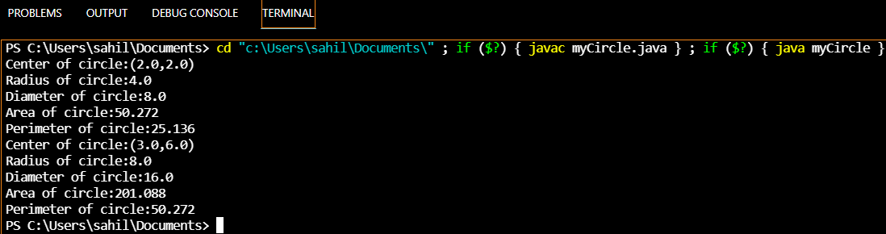

Problem statement

2.2) Define a class to represent the student details such as name, roll number, marks obtained in three internal assessment tests.

1. Identify type and declare the instance variables
2. Identify and develop the constructors to initialize the instance variables
3. Write a method computeAverage() to compute the average as the average of best two marks
4. Write a method to display the student details

Program:

import java.util.Scanner;

class student_def

{

String name;

int rollno;

int m1,m2,m3;

student_def()

{

Scanner s=new Scanner(System.in);

System.out.println("Enter the student name:");

String name=new String();

name=s.next();

System.out.println("Enter the student roll number:");

rollno=s.nextInt();

System.out.println("Enter the student marks in three subjects:");

m1=s.nextInt();

m2=s.nextInt();

m3=s.nextInt();

}

student_def(String N,int R,int M1,int M2,int M3)

{

name=N;

rollno=R;

m1=M1;

m2=M2;

m3=M3;

}

double computeAverage()

{

int min=m1;

if(m2<min)

min=m2;

if(m3<min)

min=m3;

double average=(float)((m1+m2+m3-min)/2);

return average;

}

void display()

{

System.out.println("Student details are:");

System.out.println("Student Name:"+name);

System.out.println("Student roll number:"+rollno);

System.out.println("Student marks:"+m1+","+m2+","+m3);

System.out.println("Total marks:"+(m1+m2+m3));

System.out.println("Average of best two marks:"+computeAverage());

}

}

class student

{

public static void main(String args[])

{

student_def s1=new student_def();

s1.display();

student_def s2=new student_def("Navjeet",68,27,29,26);

s2.display();

}

}

OUTPUT:

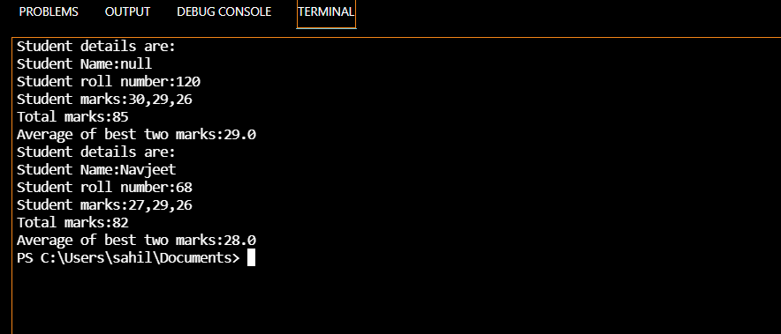

3.2) Define a class to represent a rectangle in which constructors and parameterized methods are used. It also has a method to compute area of rectangle.

1. First make a class rectangle in which we declare the parameterized constructor.
2. Then demonstrate the use of parameterized method.
3. Use a method to compute area of rectangle.
4. Create a class to demonstrate the call of the methods in previously created class rectangle holding constructors, parameterized methods and method to compute area of rectangle.

Program

class Rectangle_def

{

double l,b;

Rectangle_def()

{

l=0;

b=0;

}

Rectangle_def(double L,double B)

{

l=L;

b=B;

}

void computeArea()

{

double area=l*b;

System.out.println("Area of rectangle="+area);

}

void display()

{

System.out.println("Length="+l);

System.out.println("Breadth="+b);

}

}

class rectangle

{

public static void main(String args[])

{

Rectangle_def r1=new Rectangle_def();

r1.display();

r1.computeArea();

Rectangle_def r2=new Rectangle_def(10.5,20);

r2.display();

r2.computeArea();

}

}

OUTPUT:

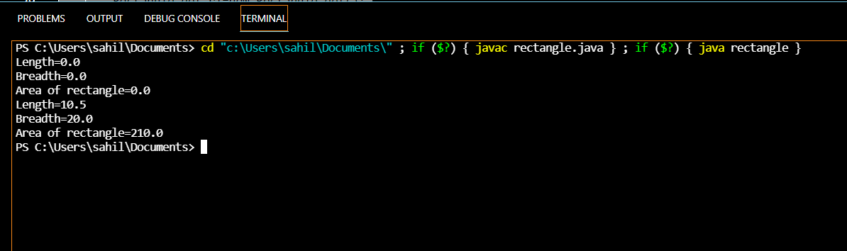

3.3) Write a Java program to represent a Complex number. Include member functions to:

1. Initialize a complex number to a default value of zero (default constructor)
2. Initialize a complex number to a user defined value (parameterized constructor)
3. Add two complex numbers and return the result. (Parameterized method)
4. Subtract two complex numbers and return the result. (Parameterized method)
5. Display a complex number. (non-parameterized method)

Program

class complex_def

{

double real,img;

complex_def()

{

real=0;

img=0;

}

complex_def(double R,double I)

{

real=R;

img=I;

}

complex_def add(complex_def c1)

{

complex_def t=new complex_def();

t.real=real+c1.real;

t.img=img+c1.img;

return t;

}

complex_def sub(complex_def c1)

{

complex_def t=new complex_def();

t.real=real-c1.real;

t.img=img-c1.img;

return t;

}

void display()

{

System.out.println("Real part="+real);

System.out.println("Imaginary part="+img);

}

}

class complex

{

public static void main(String args[])

{

complex_def c1=new complex_def(10,20);

complex_def c2=new complex_def(1,2);

complex_def c3=new complex_def();

System.out.println("Complex number 1:");

c1.display();

System.out.println("Complex number 2:");

c2.display();

System.out.println("Addition:");

c3=c1.add(c2);

c3.display();

System.out.println("Subtraction:");

c3=c1.sub(c2);

c3.display();

}

}

Output:

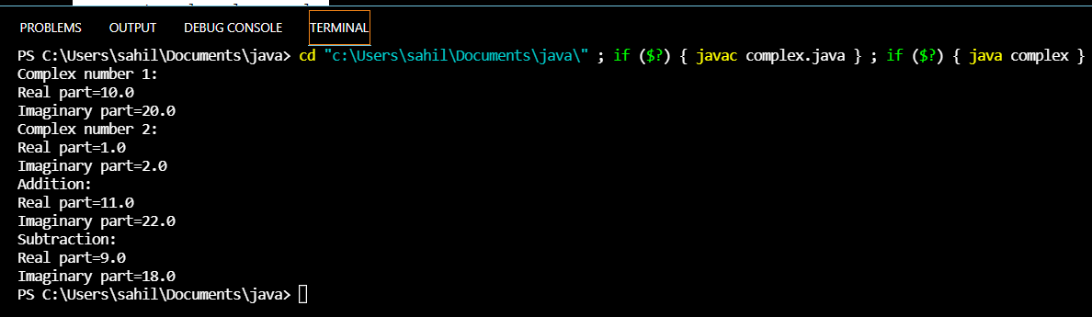

1.1) It is required to store and analyze data about 6 car manufacturer’s sales data in all the 12 months of a year. Demonstrate how you would store the data in a two dimensional matrix and do the following

1. Write a function to Find for a given car manufacturer, the month in which, maximum no. of cars are sold.
2. Write a function to Find the average number of cars sold for each car manufacturer
3. Write a function to Find the total number of cars sold for each car manufacturer.
4. Write a function to find standard deviation for a given car manufacturer

Assume – row index 0 - ‘Maruti Suzuki’, 1 – ‘Hundai’ 2 – ‘Tata Motors’ 3-‘KIA’ 4 – ‘BMW’ 5 – ‘Renault’

Col index 0 –‘Jan’, 1-‘Feb’………………………………….11 –‘Dec’

Demonstrate the working of the program with appropriate values for each car manufacturer and the months.

Program:

import java.util.Scanner;

class car {

public static void main(String[] args)

{

Scanner in=new Scanner(System.in);

int carSale[][]=new int[6][12];

int n;

for(int i=0;i<6;i++)

{

System.out.println("Enter the Sale per month for manufacturer "+(i+1)+":");

for(int j=0;j<12;j++)

{

carSale[i][j]=in.nextInt();

}

}

System.out.println("Enter the manufacturer no. to find the maximum car sold:");

n=in.nextInt();

max(carSale,n); //calling max method

System.out.println("\nThe average cars sold by");

average(carSale);

System.out.println("\nThe total carssold by ");

total(carSale);

}

static void max(int[][] carSale,int n)

{

int count=carSale[n-1][0],month=1;

for(int j=0;j<12;j++)

{

if(carSale[n-1][j]>count)

{

count=carSale[n-1][j];

month=j+1;

}

}

switch(month)

{

case 1:System.out.println("\nThe maximum number of cars sold by manufacturer "+n+" is in January.");

break;

case 2:System.out.println("\nThe maximum number of cars sold by manufacturer "+n+" is in February.");

break;

case 3:System.out.println("\nThe maximum number of cars sold by manufacturer "+n+" is in March.");

break;

case 4:System.out.println("\nThe maximum number of cars sold by manufacturer "+n+" is in April.");

break;

case 5:System.out.println("\nThe maximum number of cars sold by manufacturer "+n+" is in May.");

break;

case 6:System.out.println("\nThe maximum number of cars sold by manufacturer "+n+" is in June.");

break;

case 7:System.out.println("\nThe maximum number of cars sold by manufacturer "+n+" is in July.");

break;

case 8:System.out.println("\nThe maximum number of cars sold by manufacturer "+n+" is in August.");

break;

case 9:System.out.println("\nThe maximum number of cars sold by manufacturer "+n+" is in September.");

break;

case 10:System.out.println("\nThe maximum number of cars sold by manufacturer "+n+" is in October.");

break;

case 11:System.out.println("\nThe maximum number of cars sold by manufacturer "+n+" is in November.");

break;

case 12:System.out.println("\nThe maximum number of cars sold by manufacturer "+n+" is in December.");

break;

}

}

static void average(int[][] carSale)

{

float avg;

int sum=0;

for(int i=0;i<6;i++)

{

for(int j=0;j<12;j++)

{

sum+=carSale[i][j];

}

avg=sum/12f;

System.out.println("Manufacturer "+(i+1)+" :"+avg);

sum=0;

}

}

static void total(int[][] carSale)

{

int sum=0;

for(int i=0;i<6;i++)

{

for(int j=0;j<12;j++)

{

sum+=carSale[i][j];

}

System.out.println("Manufacturer "+(i+1)+" :"+sum);

sum=0;

}

}

}

OUTPUT:

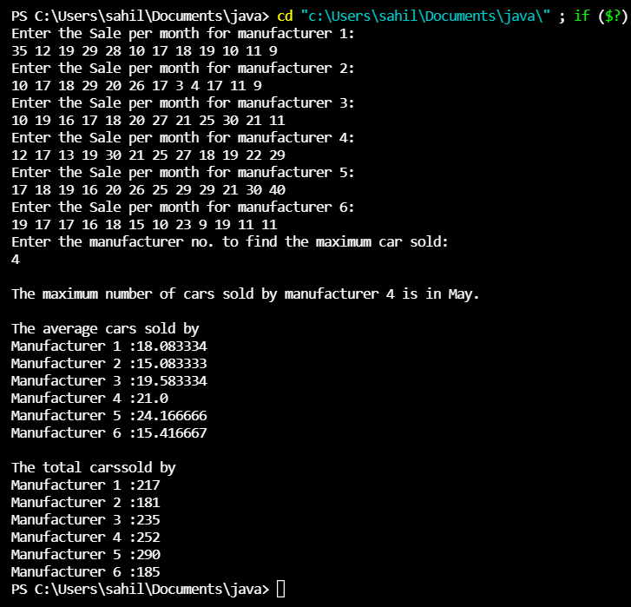

1.2) A joint family consisting of 10 households lives in the same compound. Due to mounting electricity bills, the head (Mr. X) of the joint family decides to analyze the consumption pattern (in terms of the billed amount) of each household for a year. Mr. X needs access to the following information for his analysis:

1. The total expenditure on electricity consumption by each household in a year.
2. The maximum and minimum electricity consumption of each household in a year.
3. The amount by which each household exceeded the average consumption (+/-) of all households in the month of June.
4. The maximum, minimum and average electricity consumption of all households in a year.

Demonstrate how you would use a two dimensional matrix to help Mr. X.

Program:

import java.util.Scanner;

class office

{

static int maximum(int a[])

{

int m=0,pos=0;

for(int i=0;i<10;i++)

{

if(a[i]>m)

{

m=a[i];

pos=i+1;

}

}

return pos;

}

static int minimum(int a[])

{

int m=99999,pos=0;

for(int i=0;i<10;i++)

{

if(a[i]<m)

{

m=a[i];

pos=i+1;

}

}

return pos;

}

public static void main(String[]args)

{

Scanner venki = new Scanner(System.in);

int data[][]=new int[4][10];

int i,j,max[]=new int[4];

int min[]=new int[4];

float avg[]=new float[4];

String zones[]={"North","South","East","West"};

System.out.println("Enter the data of the zones : ");

for(i=0;i<4;i++)

{

System.out.println("\n"+zones[i]+" : ");

int sum=0;

for(j=0;j<10;j++)

{

System.out.println("Office "+(j+1)+" : ");

data[i][j]=venki.nextInt();

sum+=data[i][j];

}

avg[i]=sum/10;

max[i] = maximum(data[i]);

min[i] = minimum(data[i]);

}

System.out.println("\nOffice Number with highest sales zone wise : ");

for(i=0;i<4;i++)

System.out.println(zones[i]+" : "+max[i]);

System.out.println("\nOffice with poorest sales zone wise : ");

for(i=0;i<4;i++)

System.out.println(zones[i]+" : "+min[i]);

System.out.println("\nAverage sales zone wise : ");

for(i=0;i<4;i++)

System.out.println(zones[i]+" : "+avg[i]);

}

}

OUTPUT:

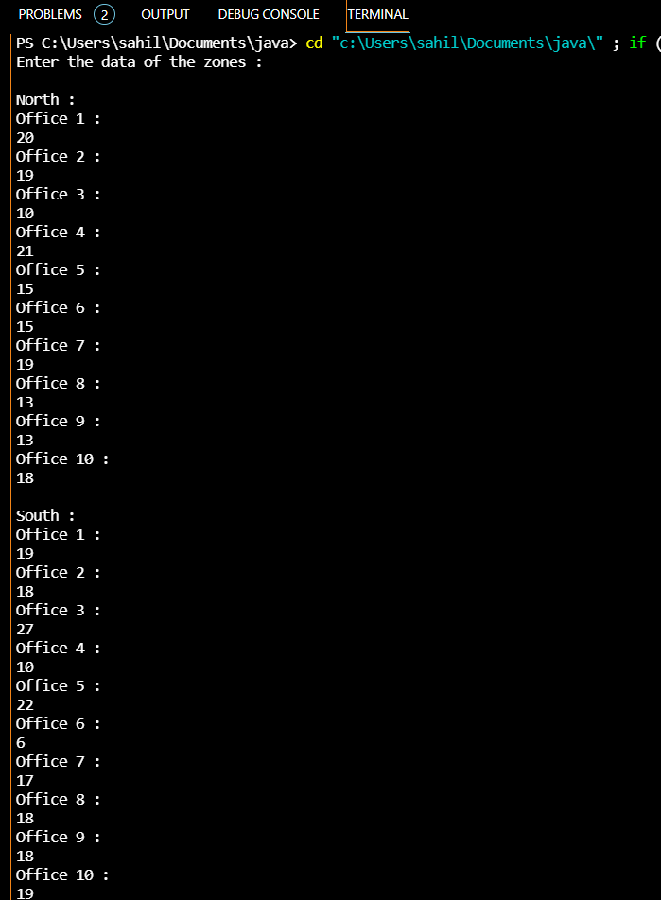

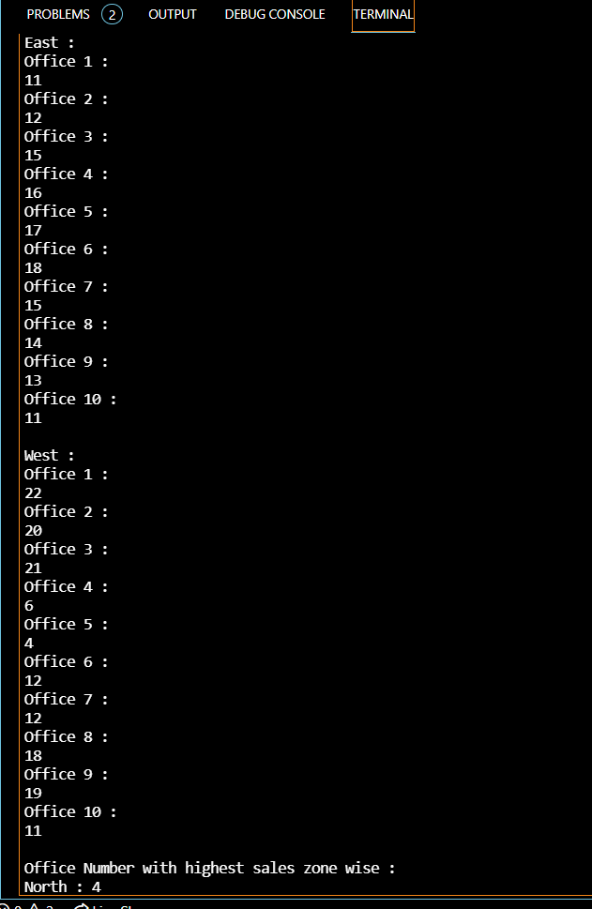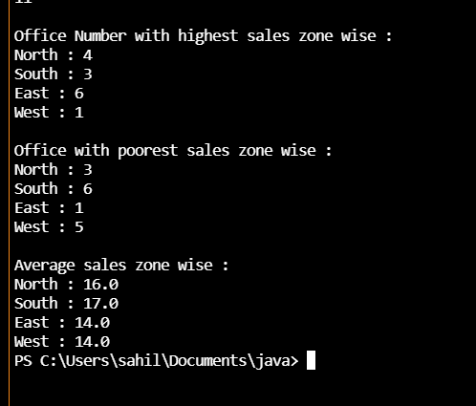

TERMWORK:1

NAME: SAHIL HALGEKAR

USN 2GI20CS120

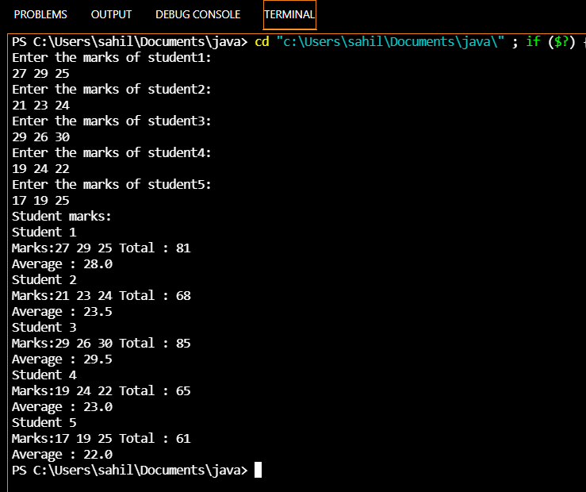

TERMWORK:2

NAME: SAHIL HALGEKAR

USN 2GI20CS120

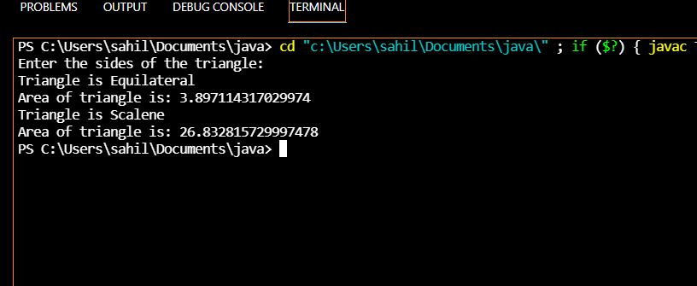

TERMWORK:3

NAME: SAHIL HALGEKAR

USN 2GI20CS120

